**ELECTIVE 3: FULLSTACK WEB DEVELOPMENT**

**PRELIMINARY EXAMINATION**

**1st Semester, Academic Year 2019-2020**

Please follow the directions for each section. Note that in each section you will have some amount of choice in the questions you’ll be answering. The exam is based on a 100-point scale. Partial credit will be given for answers that are done partially well.

**Programming** (50 points ).

1. Create a basic website (without JavaScript) that has the following layout below with the ff. Instructions
   1. Should be posted in Github with the format E3PE_LASTNAME_FIRSTNAME for the project name.
   2. Follow layout below:

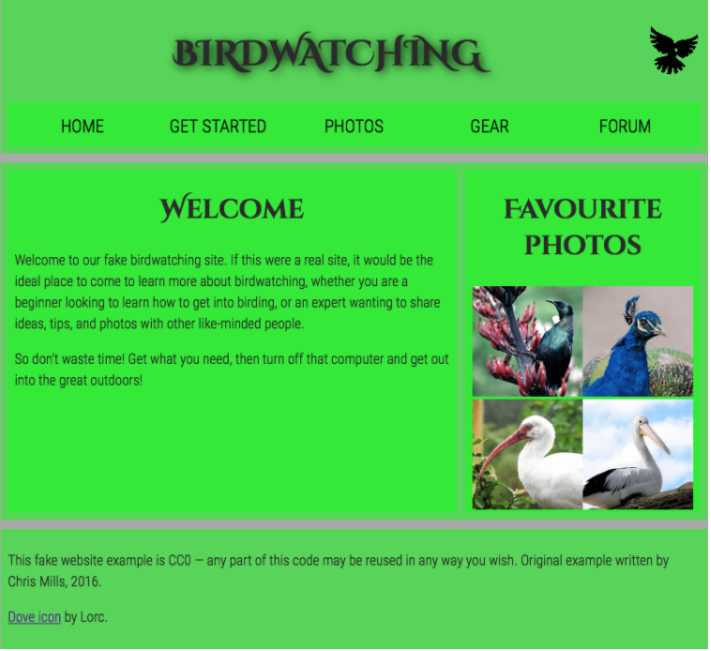

* 1. Logos and pictures can be changed.
  2. Fonts can be altered.

**GitHub Link:** https://github.com/michelleespeleta/E3PE_ESPELETA_MICHELLE

**Essay** (25 points):

1. How would you say that front-end development has evolved over the years? State some key difference from then (like 10 years ago) to now.

* I would say that front-end development evolved more complex over the years compared from the beginning of front-end development. Before, a standard webpage only uses HTML, CSS, and JavaScript. The developer or front-end developer only do three simple things to have a functioning website which are write and save the code, open, and make sure they work properly in a browser, then publish it in a website hosting page. However, as the years goes on the requirement for a web platform were getting more complex. Because of this the developers of JavaScript made frameworks and libraries to lessen the time of coding. In today's time, there are tons of custom tools to use which challenges the web developers today because they don't know which one to use. In addition, before we only had static web pages made from HTML but now we have interactive websites.

1. Provide a code snippet that shows CSS precedence between element selectors, class selectors and inline styling.

* Code snippet for CSS element selectors:

<!DOCTYPE html>

<html>

<head>

<style>

p {

text-align: center;

color: red;

}

</style>

</head>

<body>

<p>Every paragraph will be affected by the style.</p>

<p id="para1">Me too!</p>

<p>And me!</p>

</body>

</html>

* Code snippet for CSS class selectors:

<!DOCTYPE html>

<html>

<head>

<style>

.center {

text-align: center;

color: red;

}

</style>

</head>

<body>

<h1 class="center">Red and center-aligned heading</h1>

<p class="center">Red and center-aligned paragraph.</p>

</body>

</html>

* Code snippet for CSS inline styling:

<!DOCTYPE html>

<html>

<body>

<h1 style="color:blue;">A Blue Heading</h1>

<p style="color:red;">A red paragraph.</p>

</body>

</html>

|  |  |  |
| --- | --- | --- |
| Prepared By:  NINO FRANCISCO ALAMO  Professor /Instructor | Reviewed By:  REGIE ELLANA  CCS Dean | Approved By:  DR. LEAH DIGO  VP for Academic Affairs |

|  |
| --- |
| **LOA-OAA-TOS-028** |
| **10-02-2020 | REV. 00** |

|  |  |
| --- | --- |
| **CODE** | **ELEC323** |
| **TITLE** | **ELECTIVE 3: FULLSTACK DEVELOPMENT** |
| **EXAM** | **PRELIMINARY EXAMINATION** |
| **TERM/AY** | **2ND SEMESTER, ACADEMIC YEAR 2019-2020** |

|  |  |  |  |  |  |  |  |  |
| --- | --- | --- | --- | --- | --- | --- | --- | --- |
| **Topic #** | **Objectives** | **Remember** | **Understand** | **Apply** | **Analyze** | **Evaluate** | **Create** | **Total # of Items/points** |
| 1 | * To apply the concepts of MVC   + - * + Creating Views         + Persisting to Database | 2 | 2 | 2 | 1 | 1 | 2 | **10** |
| **Total # of items/Points** | | 2 | 2 | 2 | 1 | 1 | **2** | **10** |

|  |  |  |
| --- | --- | --- |
| Prepared By:  NINO FRANCISCO ALAMO  Professor /Instructor | Reviewed By:  REGIE ELLANA  CCS Dean | Approved By:  DR. LEAH DIGO  VP for Academic Affairs |